Sermon Notes

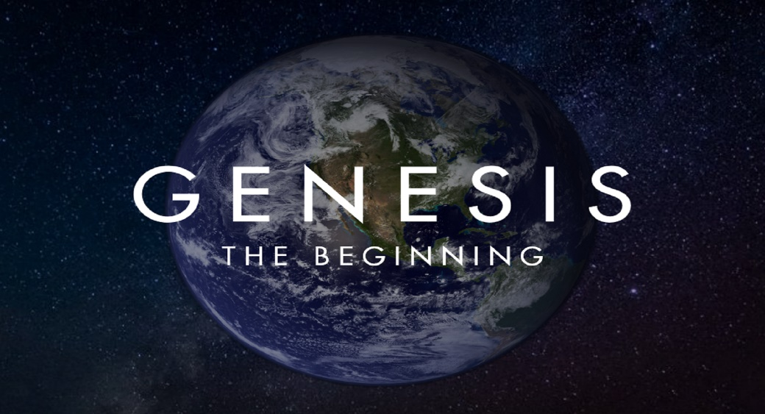

Welcome to Boyle Gospel Chapel
May 22, 2022

We would like to thank you for sharing part of your day with us! With Bible-based teaching, family-centered programs and a friendly atmosphere, Boyle Gospel Chapel opens its doors to you!

Boyle Gospel Chapel is affiliated with Village Missions of Canada. Check out their website at: villagemissions.ca.

5101-5 Street, Boyle, AB T0A 0M0
(780) 689-4071
boylegospelchapel@gmail.com
www.boylegospelchapel.ca

Check us out:
Worship with Us

Welcome & Announcements
Call to Worship (Revelation 22:1-5)
Song: O Worship the King
Song: Immortal, Invisible, God Only Wise
Prayer & Praise
Song: Whate’er My God Ordains is Right
Song: Creation Sings the Father’s Song
Sermon
Sermon Series: Genesis – The Beginning
Sermon Title: “Filling the Earth”
Sermon Text: Genesis 1:14-31
Song: All People That on Earth Do Dwell
Benediction
**Fellowship Meal to follow**

Children’s Ministry

There is Sunday School for children, during the sermon.
There is an unsupervised nursery at the back of the church for mothers with little ones.

This Week’s Events

Wednesday, May 25
Ladies Prayer Meeting
10:00 am @ the Chapel
Friday, May 27
Youth Group
7:30 pm
Saturday, May 28
Church Cleaning Day
1:00 pm @ the Chapel
Sunday, May 29
10:00 am Remembrance Service
11:00 am Family Bible Hour
Sermon Series: Genesis – The Beginning
Sermon Title: “God Rested”
Sermon Text: Genesis 2:1-3

Announcements

Pregnancy Care Centre Baby Bottle Campaign
May 8 - June 19
~ Did you know that when you give to the Baby Bottle Campaign you are giving mothers support services that can continue through their baby's first years? The Pregnancy Care Centre does not only offer pregnancy tests and options support, they also have Pregnancy Plus classes where new moms (and dads) can learn about developing baby, parenting, and life skills. Please continue filling your bottle to keep free services like these available for the families who need them.

