**Sermon Notes**

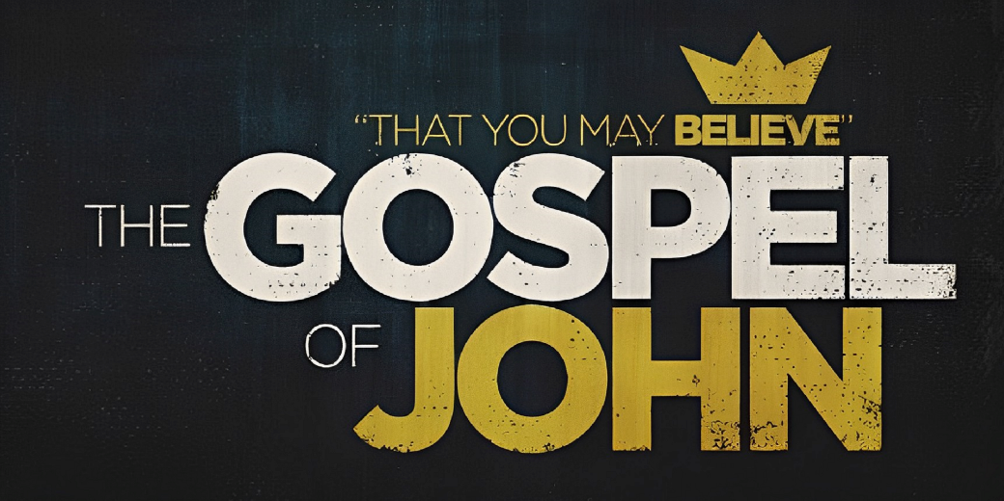

**Welcome to Boyle Gospel Chapel**

July 21, 2024

We are glad you are here! Whether you are visiting for the first time or you’ve been here for years, we would like to thank you for sharing part of your day with us! With Bible-based teaching, family-centered programs and a friendly atmosphere, Boyle Gospel Chapel opens its doors to you!

Boyle Gospel Chapel is affiliated with Village Missions of Canada. Check out their website at: villagemissions.ca.

5101-5 Street, Boyle, AB T0A 0M0

(780) 689-4071

boylegospelchapel@gmail.com

www.boylegospelchapel.ca

Check us out:

**Worship with Us**

Welcome & Announcements

Call to Worship (Psalm 25:4-5)

Song: Only a Holy God

Song: My Jesus, I Love Thee

Prayer & Praise

Song: Christ is Mine Forevermore

Song: Take My Life and Let It Be

Sermon

Sermon Series: John – That You May Believe

Sermon Title: “To Whom Shall We Go?”

Sermon Text: John 6:60-71

Song: I Surrender All

Benediction

**Children’s Ministry**

There is no Sunday School during the summer.

There is an unsupervised nursery at the back of the church for mothers with little ones.

**This Week’s Events**

**Wednesday, July 24**

Ladies Prayer Meeting

10:00 am @ the Chapel

**Sunday, July 28**

10:00 am Remembrance Service

11:00 am Family Bible Hour

Sermon Series: John – That You May Believe

Sermon Title: “Can This Be the Christ?”

Sermon Text: John 7:1-36

12:15 pm Fellowship Meal

**Announcements**

**The Great Jungle Journey VBS**

August 12-16 (9:00 am - 12:00 pm)

Vacation Bible School is a FREE 5-day summer program for children ages 5-12. At *The Great Jungle Journey VBS*, kids will explore biblical answers to their questions as they set off on an epic adventure from Genesis to Revelation. For more information or to register your children, please visit:

www.boylegospelchapel.ca/vbs.