**Sermon Notes**

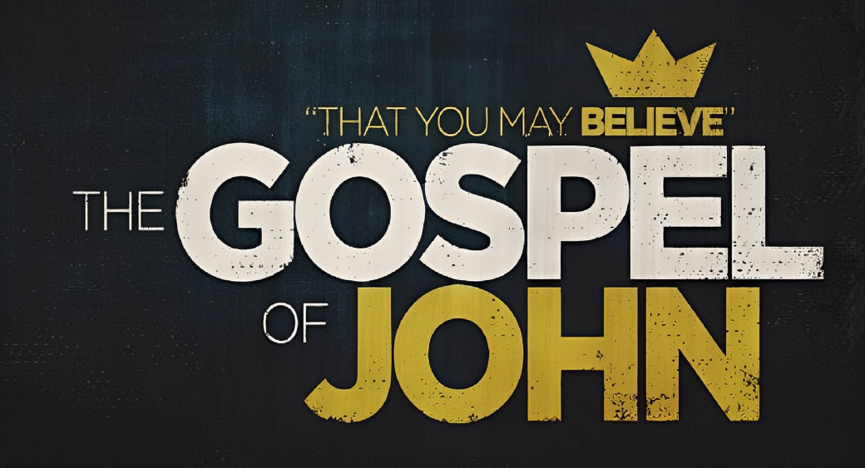

**Welcome to Boyle Gospel Chapel**

October 6, 2024

We are glad you are here! Whether you are visiting for the first time or you’ve been here for years, we would like to thank you for sharing part of your day with us! With Bible-based teaching, family-centered programs and a friendly atmosphere, Boyle Gospel Chapel opens its doors to you!

Boyle Gospel Chapel is affiliated with Village Missions of Canada. Check out their website at: villagemissions.ca.

5101-5 Street, Boyle, AB T0A 0M0

(780) 689-4071

boylegospelchapel@gmail.com

www.boylegospelchapel.ca

Check us out:

**Worship with Us**

Welcome & Announcements

Call to Worship (Psalm 100)

Song: Praise Him! Praise Him! (#59)

Song: A Mighty Fortress Is Our God (#11)

Prayer & Praise

Song: My Saviour’s Love (I Stand Amazed) (#256)

Song: Mansion Over the Hilltop (#536)

Sermon

Sermon Series: John – That You May Believe

Sermon Title: “I Am the Good Shepherd”

Sermon Text: John 10:11-21

Song: Leaning On the Everlasting Arms (#240)

Benediction

**Children’s Ministry**

There is Sunday School for children during the sermon.

There is an unsupervised nursery at the back of the church for mothers with little ones.

**This Week’s Events**

**Tuesday, October 8**

Ladies Bible Study

10:00 am @ the Chapel

**Wednesday, October 9**

Ladies Prayer Meeting

10:00 am @ the Chapel

**Friday, October 11**

Youth Group

7:30 pm @ the Chapel

**Saturday, October 12**

Men’s Breakfast

8:00 am @ the Chapel

**Sunday, October 13**

10:00 am Remembrance Service

11:00 am Family Bible Hour

Sermon Series: John – That You May Believe

Sermon Title: “I and the Father Are One”

Sermon Text: John 10:22-42

12:15 pm Fellowship Meal

**Announcements**

**Samaritan’s Purse Operation Christmas Child Shoeboxes**

You can grab a shoebox and a pamphlet from the back table. The Shoebox Collection Date is Sunday, November 17. The $12 donation is being covered by the Chapel. If you would like to pack a shoebox online, you can visit:

secure.samaritanspurse.ca/campaign/donateabox/.