**Sermon Notes**

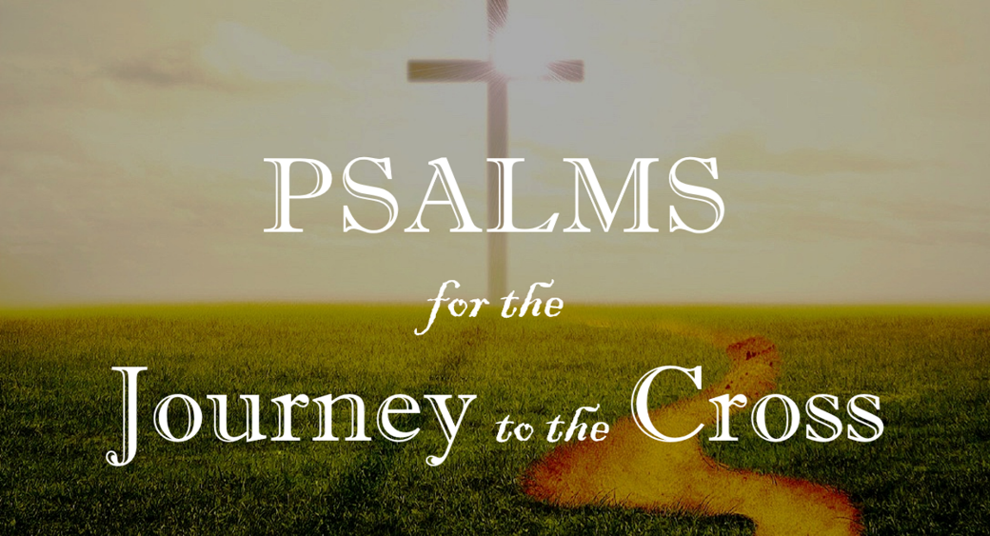

**Welcome to Boyle Gospel Chapel**

April 13, 2025

We are glad you are here! Whether you are visiting for the first time or you’ve been here for years, we would like to thank you for sharing part of your day with us! With Bible-based teaching, family-centered programs and a friendly atmosphere, Boyle Gospel Chapel opens its doors to you!

Boyle Gospel Chapel is affiliated with Village Missions of Canada. Check out their website at: villagemissions.ca.

5101-5 Street, Boyle, AB T0A 0M0

(780) 689-4071

boylegospelchapel@gmail.com

www.boylegospelchapel.ca

Check us out:

**Worship with Us**

Welcome & Announcements

Call to Worship (Psalm 118:24-26)

Song: In the Garden (#19)

Song: For Those Tears I Died (#323)

Prayer & Praise

Song: Jesus Is Lord of All (#67)

Song: Jesus, the Very Thought of Thee (#163)

Sermon

Sermon Series: Psalms for the Journey to the Cross

Sermon Title: “Make a Joyful Noise to the Lord,

All the Earth”

Sermon Text: Psalm 100

Song: Rejoice, the Lord is King

Benediction

**Fellowship Meal to follow**

**Children’s Ministry**

There is Sunday School for children during the sermon.

There is an unsupervised nursery at the back of the church for mothers with little ones.

**This Week’s Events**

**Today**

Chapel Service

3:00 pm @ Wildrose Villa

**Tuesday, April 15**

Ladies Bible Study (Joshua)

10:00 am @ the Chapel

Youth Bible Study (Proverbs)

7:00 pm @ the Peters’ (5313 Willow Drive South, Boyle)

**Wednesday, April 16**

Ladies Prayer Meeting

10:00 am @ the Chapel

**Friday, April 18**

Good Friday Service

7:00 pm @ the Chapel

**Sunday, April 20**

10:00 am Remembrance Service

11:00 am Family Bible Hour

Sermon Series: Psalms for the Journey to the Cross

Sermon Title: “The Path of Life”

Sermon Text: Psalm 16

**Announcements**

**Good Friday Service**

April 18 @ 7:00 pm at the Chapel

Join us on Good Friday as we gather to remember the suffering and death of our Lord Jesus Christ. Through Scripture and song, we will journey to the cross, considering the depth of Christ’s love and the

price he paid for our redemption.

**Baptism**

Our Resurrection Service next Sunday (April 20) will include a baptism. Join us in celebrating new life in Christ!