**Sermon Notes**

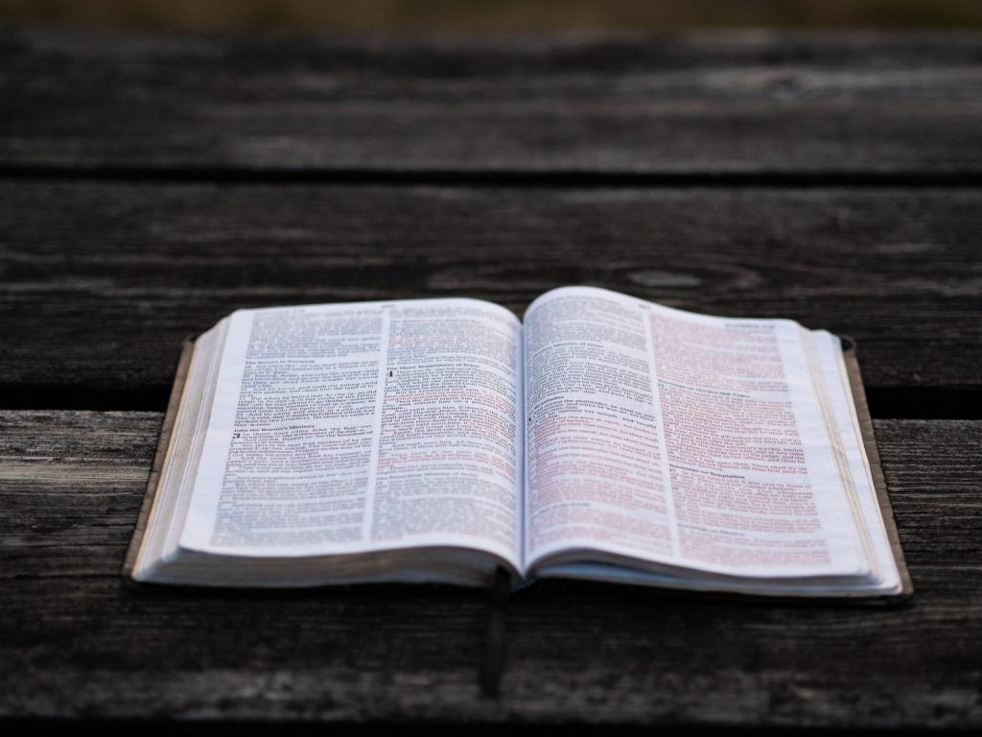

**Welcome to Boyle Gospel Chapel**

June 29, 2025

We would like to thank you for sharing part of your day with us! With Bible-based teaching, family-centered programs and a friendly atmosphere, Boyle Gospel Chapel opens its doors to you!

Boyle Gospel Chapel is affiliated with Village Missions of Canada. Check out their website at: villagemissions.ca.

5101-5 Street, Boyle, AB T0A 0M0

(780) 689-4071

boylegospelchapel@gmail.com

www.boylegospelchapel.ca

Check us out:

|  |  |  |
| --- | --- | --- |
| **Worship With Us** | **Upcoming Events** | |
|  |  | |
| Welcome & Announcements  Call to Worship (Titus 2:11-15)  Song: Fill My Cup (#220)  Song: Heaven Came Down (#183)  Praise & Prayer  Song: What a Day That Will Be  Song: Spirit of God (#13)  Sermon  Guest Speaker: Tim McClintic  Sermon Text: Psalm 73  Sermon Title: “Faith Restored”  Song: How Great Thou Art (#2)  Benediction  **Children’s Ministry**  Sunday School is available for children during the sermon.  This will be the last Sunday School before the summer.  There is an unsupervised nursery at the back of the church for mothers with little ones. | **Wednesday, July 2**  **Ladies Prayer Meeting**  10:00 am @ the Chapel  **Thursday, July 3**  **Mission Eurasia Canada Info Night**  7:00 pm @ the Peters’ (5313 Willow Drive South, Boyle)  Join us for an evening with Gordon & Sue Balfour, as they introduce the new executive director of Mission Eurasia Canada. They would also like to thank our church for the support of the Action Bible New Testament project.  **Saturday, July 5**  **The Elias Family Concert**  1:00 pm @ Athabasca  Riverfront Stage  **Saturday, July 5**  **Leadership Meeting**  7:00 pm @ the Chapel  **Sunday, July 6**  10:00 am Remembrance Service  11:00 am Family Bible Hour  Sermon Text: John 19:31-42 | **Saturday, July 12**  **Men’s Breakfast**  8:00 am @ the Chapel  **August 11-15**  **Wonder Junction VBS**  9:00 am - 12:00 pm  Vacation Bible School is a FREE 5-day summer program for children ages 5-12. At *Wonder Junction VBS*, kids will discover the wonder of who Jesus is. For more information or to register your children, please visit: www.boylegospelchapel.ca/vbs. |