Sermon Notes

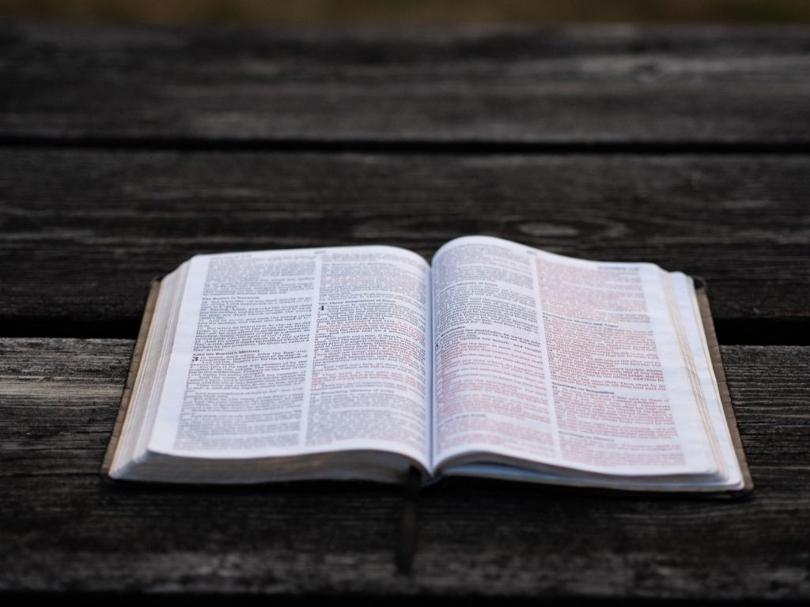

Welcome to Boyle Gospel Chapel
November 23, 2025

We would like to thank you for sharing part of your day with us! With Bible-based teaching, family-centered programs and a friendly atmosphere, Boyle Gospel Chapel opens its doors to you!

Boyle Gospel Chapel is affiliated with Village Missions of Canada. Check out their website at: villagemissions.ca.

5101-5 Street, Boyle, AB T0A 0M0
(780) 689-4071
boylegospelchapel@gmail.com
www.boylegospelchapel.ca

Check us out:



Worship With Us | Upcoming Events
Welcome & Announcements  Call to Worship (Based on Exodus 15:1-2)  Leader: Sing to the Lord, for he has triumphed gloriously.  ALL: The Lord is my strength and my song,  and he has become my salvation;  this is my God, and I will praise him.  Song: The Church’s One Foundation (#77)  Song: My Faith Looks Up to Thee (#33)  Praise & Prayer  Song: The Lily of the Valley (#310)  Song: Jesus Paid It All (#146)  Sermon  Sermon Title: “Teach Us to Number Our Days”  Sermon Text: Psalm 90  Song: Go, Tell It on the Mountain (#127)  Benediction  **Fellowship Meal to follow**  Deeper Study  Heidelberg Catechism Q. 2) How many things must you know to live and die in the joy of this comfort?  A) Three: first, how great my sin and misery are; second, how I am delivered from all my sins and misery; third, how I am to thank God for such deliverance. | Tuesday, November 25  Youth Bible Study  7:00 pm @ the Peters’  (5313 Willow Drive South, Boyle)  Wednesday, November 26  Ladies Prayer Meeting  10:00 am @ the Chapel  Adult Bible Study  7:00 pm @ the Peters’  (5313 Willow Drive South, Boyle)  Friday, November 28  Youth Group  7:30 pm @ the Chapel  Sunday, November 30  10:00 am Remembrance Service  11:00 am Family Bible Hour  Sermon Text: Isaiah 9:6-7  Friday, December 5  Community Praise & Prayer  7:00 pm @ the Chapel | Saturday, December 6  Leadership Meeting  7:00 pm @ the Chapel  Saturday, December 13  Men’s Breakfast  8:00 am @ the Chapel  Sunday, December 14  Chapel Service  3:00 pm @ Wildrose Villa

