Sermon Notes

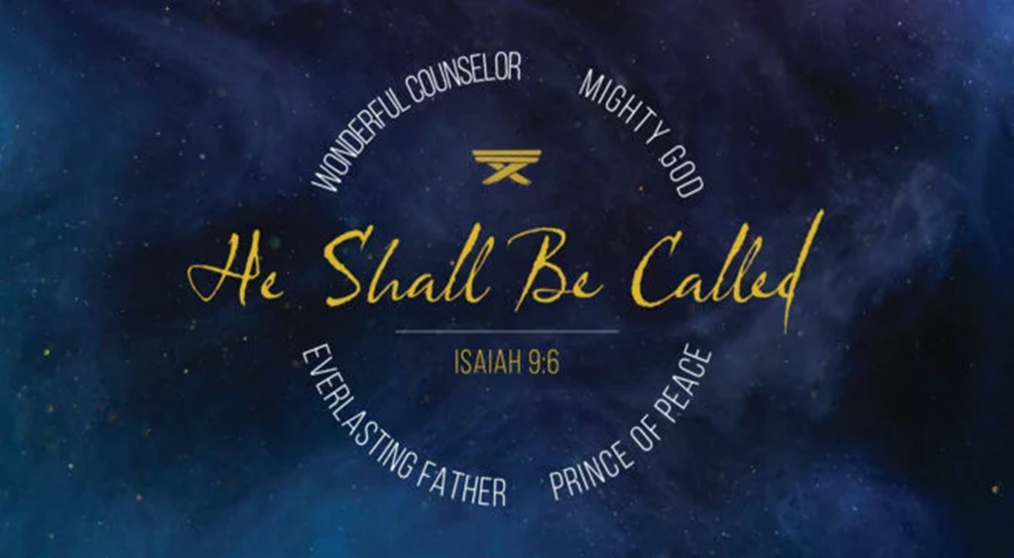

Welcome to Boyle Gospel Chapel
December 21, 2025

We would like to thank you for sharing part of your day with us! With Bible-based teaching, family-centered programs and a friendly atmosphere, Boyle Gospel Chapel opens its doors to you!

Boyle Gospel Chapel is affiliated with Village Missions of Canada. Check out their website at: villagemissions.ca.

5101-5 Street, Boyle, AB T0A 0M0
(780) 689-4071
boylegospelchapel@gmail.com
www.boylegospelchapel.ca

Check us out:



Worship With Us  Welcome & Announcements  Call to Worship (Isaiah 51:1, 3)  Leader: Listen to me, you who pursue righteousness, you who seek the Lord: look to the rock from which you were hewn, and to the quarry from which you were dug…. For the Lord comforts Zion; he comforts all her waste places and makes her wilderness like Eden, her desert like the garden of the Lord; joy and gladness will be found in her, thanksgiving and the  voice of song.  Song: It Came Upon the Midnight Clear (#118)  Song: Angels from the Realms of Glory (#124)  Praise & Prayer  Song: I Heard the Bells on Christmas Day (#123)  Song: The First Noel (#120)  Sermon  Sermon Series: The Christ of Christmas  Sermon Title: “Prince of Peace”  Sermon Text: Isaiah 9:6-7  Song: O Holy Night  Benediction |  | Upcoming Events  Tuesday Youth Bible Study @ 7:00pm at the Peters’  (5313 Willow Drive South, Boyle)  Wednesday Ladies Prayer Meeting @ 10:00am at the Chapel  Christmas Eve Service @ 7:00pm at the Chapel  Sunday Remembrance Service @ 10:00am  Family Bible Hour @ 11:00am  Sermon Text: Luke 2:8-20  Fellowship Meal @ 12:15pm  January 3 Leadership Meeting @ 7:00pm at the Chapel  January 10 Men’s Breakfast @ 8:00am at the Chapel  January 11 Chapel Service @ 3:00pm at Wildrose Villa  January 24 Annual General Meeting @ 3:00pm at the Chapel  Deeper Study  Heidelberg Catechism  Q. 7) Then where does man’s corrupt nature come from?  A) From the fall and disobedience of our first parents, Adam and Eve, in Paradise. This fall has so poisoned our nature that we are all conceived and born in sin.  Advent Bible Reading Plan  Sunday, December 21 – Zechariah 9:9-17; 13:1-9; Malachi 3:1-4  Monday, December 22 – Luke 1:26-56  Tuesday, December 23 – Luke 1:57-80  Wednesday, December 24 – Luke 2:1-20  Thursday, December 25 – John 1:1-18

