Sermon Notes

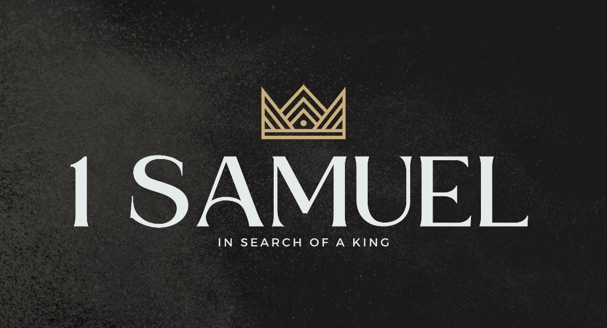

Welcome to Boyle Gospel Chapel
April 12, 2026

We’re glad you are here! We would like to thank you for sharing part of your day with us! With Bible-based teaching, family-centered programs, and a friendly atmosphere, Boyle Gospel Chapel opens its doors to you!

Boyle Gospel Chapel is affiliated with Village Missions of Canada. Learn more at: villagemissions.ca.

5101 – 5 Street, Boyle, AB T0A 0M0
(780) 689-4071
boylegospelchapel@gmail.com
www.boylegospelchapel.ca

Connect With Us



Worship With Us  Welcome & Announcements  Call to Worship (Psalm 98:1-2)  Leader: Oh sing to the Lord a new song,  for he has done marvelous things!  His right hand and his holy arm  have worked salvation for him.  The Lord has made known his salvation;  he has revealed his righteousness  in the sight of the nations.  Song: Praise to the Lord, the Almighty (#37)  Song: Christ Is Mine Forevermore  Praise & Prayer  Song: A Mighty Fortress Is Our God (#11)  Song: The Church’s One Foundation (#77)  Sermon  Sermon Series: 1 Samuel – In Search of a King  Sermon Title: “The Hidden King”  Sermon Text: 1 Samuel 10:17-27  Song: Crown Him With Many Crowns (#30)  Benediction  **Fellowship Meal to follow**  Children’s Ministry  There is Sunday School for children. There is an unsupervised nursery at the back of the church for parents with little ones.  Giving  If you would like to support the ministry of BGC, you may give:  - In the offering box at the back of the sanctuary.  - By e-transfer to: bgcbanking@gmail.com – please include your name and address for tax receipt purposes. |  | Upcoming Events  Today Chapel Service @ 3:00pm at Wildrose Villa  Tuesday Youth Bible Study @ 7:00pm at the Peters’  (5313 Willow Drive South, Boyle)  Wednesday Ladies Prayer Meeting @ 10:00am at the Chapel  Friday Youth Group @ 7:30pm at the Chapel  Sunday Remembrance Service @ 10:00am  Family Bible Hour @ 11:00am  Sermon Text: 1 Samuel 11:1-15  Deeper Study  Heidelberg Catechism  Q. 23) What are these articles?  A) I believe in God, the Father Almighty, Creator of heaven and earth. I believe in Jesus Christ, his only begotten Son, our Lord, who was conceived by the Holy Spirit, born of the virgin Mary; suffered under Pontius Pilate, was crucified, dead, and buried; he descended into hell; the third day he rose again from the dead; he ascended to heaven, and sits at the right hand of God the Father Almighty; from there he will come to judge the living and the dead. I believe in the Holy Spirit; the holy catholic church; the communion of saints; the forgiveness of sins; the resurrection of the body; and the life  everlasting. Amen.  Chronological Bible Reading Plan  Sunday, April 12 – 1 Samuel 15-17  Monday, April 13 – 1 Samuel 18-20; Psalm 11; Psalm 59  Tuesday, April 14 – 1 Samuel 21-24  Wednesday, April 15 – Psalm 7; Psalm 27; Psalm 31; Psalm 34; Psalm 52  Thursday, April 16 – Psalm 56; Psalm 120; Psalm 140-142  Friday, April 17 – 1 Samuel 25-27  Saturday, April 18 – Psalm 17; Psalm 35; Psalm 54; Psalm 63

