Sermon Notes

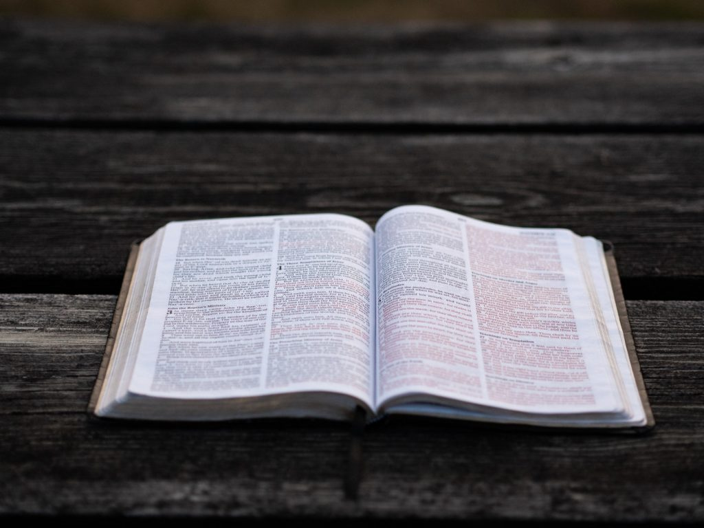

Welcome to Boyle Gospel Chapel
August 30, 2026

We’re glad you are here! Whether you are visiting for the first time or you’ve been here for years, we would like to thank you for sharing part of your day with us! With Bible-based teaching, family-centered programs, and a friendly atmosphere, Boyle Gospel Chapel opens its doors to you!

Boyle Gospel Chapel is affiliated with Village Missions of Canada. Learn more at: villagemissions.ca.

5101 – 5 Street, Boyle, AB T0A 0M0
(780) 689-4071
boylegospelchapel@gmail.com
www.boylegospelchapel.ca

Connect With Us



Worship With Us  Welcome & Announcements  Call to Worship (Based on Psalm 103:1; Luke 1:46-47)  Leader: Bless the Lord; let all that is within you  bless his holy name!  ALL: My soul magnifies the Lord,  and my spirit rejoices in God my Savior.  Song: Ten Thousand Angels (#142)  Song: Since Jesus Came Into My Heart (#259)  Prayer & Praise  Song: Break Thou the Bread of Life (#113)  Song: Seek Ye First  Sermon  Song: What a Friend We Have in Jesus (#100)  Benediction  Children’s Ministry  There is no Sunday School during the summer.  Giving  If you would like to support the ministry of BGC, you may give:  - In the offering box at the back of the sanctuary.  - By e-transfer to: bgcbanking@gmail.com – please include your name and address for tax receipt purposes. |  | Upcoming Events  Wednesday Ladies Prayer Meeting @ 10:00am at the Chapel  Sunday Remembrance Service @ 10:00am  Family Bible Hour @ 11:00am  Sermon Text: 1 Samuel 20:1-42  September 3-7 Yard Sale @ 9:00am – 8:00pm at Gateway Community  Church; all proceeds go toward the Action Bible New  Testament project in Ukraine; for more information  contact Barry Sawka at: (780) 689-2128.  September 3 Leadership Meeting @ 7:00pm at the Chapel  September 12 Men’s Breakfast @ 8:00am at the Chapel  September 13 Chapel Service @ 3:00pm at Wildrose Villa  Deeper Study  Heidelberg Catechism  Q. 43) What further benefit do we receive from Christ’s sacrifice and death on the cross?  A) By his power our old man is crucified, put to death, and buried with him, so that the evil desires of the flesh may no longer rule us, but that instead we may offer ourselves as a sacrifice of thanksgiving  to him.  Chronological Bible Reading Plan  Sunday, August 30 – Ezekiel 13-15  Monday, August 31 – Ezekiel 16-17  Tuesday, September 1 – Ezekiel 18-19  Wednesday, September 2 – Ezekiel 20-21  Thursday, September 3 – Ezekiel 22-23  Friday, September 4 – Ezekiel 24-27  Saturday, September 5 – Ezekiel 28-31

