**Sermon Notes**

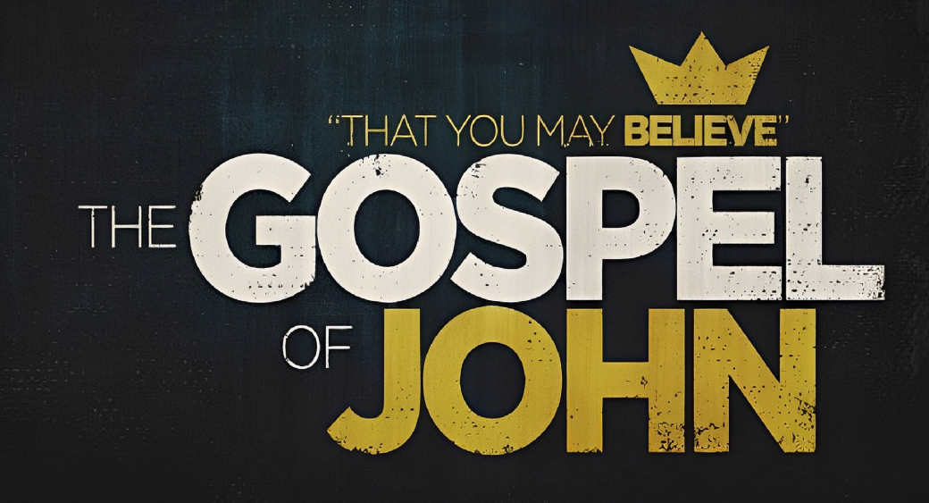

**Welcome to Boyle Gospel Chapel**

January 19, 2025

We are glad you are here! Whether you are visiting for the first time or you’ve been here for years, we would like to thank you for sharing part of your day with us! With Bible-based teaching, family-centered programs and a friendly atmosphere, Boyle Gospel Chapel opens its doors to you!

Boyle Gospel Chapel is affiliated with Village Missions of Canada. Check out their website at: villagemissions.ca.

5101-5 Street, Boyle, AB T0A 0M0

(780) 689-4071

boylegospelchapel@gmail.com

www.boylegospelchapel.ca

Check us out:

**Worship with Us**

Welcome & Announcements

Call to Worship (Philippians 2:5-11)

Song: Be Thou My Vision

Song: Jesus, Strong and Kind

Prayer & Praise

Song: God Move in a Mysterious Way

Song: Take My Life and Let It Be

Sermon

Sermon Series: John – That You May Believe

Sermon Title: “Lord and Servant”

Sermon Text: John 13:1-20

Song: O Church Arise

Benediction

**Children’s Ministry**

There is Sunday School for children during the sermon.

There is an unsupervised nursery at the back of the church for mothers with little ones.

**This Week’s Events**

**Tuesday, January 21**

Youth Bible Study

7:00 pm @ the Peters’ (5313 Willow Drive South, Boyle)

**Wednesday, January 22**

Ladies Prayer Meeting

10:00 am @ the Chapel

Adult Bible Study

7:00 pm @ the Peters’ (5313 Willow Drive South, Boyle)

**Friday, January 24**

Youth Group

7:30 pm @ the Chapel

**Saturday, January 25**

Annual General Meeting

3:00 pm @ the Chapel

**Sunday, January 26**

10:00 am Remembrance Service

11:00 am Family Bible Hour

Sermon Series: John – That You May Believe

Sermon Title: “A New Commandment”

Sermon Text: John 13:21-38

12:15 pm Fellowship Meal

**Announcements**

**Annual General Meeting**

Everyone is encouraged to attend as we reflect on the past year and conduct important church business, but only those who confess Jesus Christ as Saviour and Lord, who agree with the statement of faith of the church, and who have regularly attended within the last six months can vote.