Sermon Notes

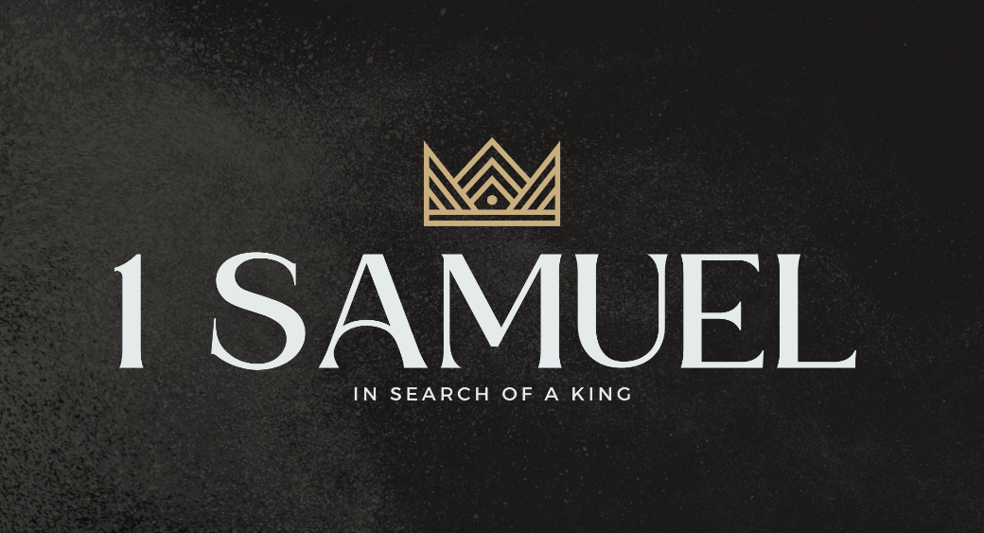

Welcome to Boyle Gospel Chapel
January 25, 2026

We would like to thank you for sharing part of your day with us! With Bible-based teaching, family-centered programs and a friendly atmosphere, Boyle Gospel Chapel opens its doors to you!

Boyle Gospel Chapel is affiliated with Village Missions of Canada. Check out their website at: villagemissions.ca.

5101-5 Street, Boyle, AB T0A 0M0
(780) 689-4071
boylegospelchapel@gmail.com
www.boylegospelchapel.ca

Check us out:



Worship With Us  Welcome & Announcements  Call to Worship (Revelation 5:12; Isaiah 6:3)  Leader: Worthy is the Lamb who was slain,  to receive power and wealth  and wisdom and might and honor  and glory and blessing!  People: Holy, holy, holy is the Lord of hosts;  the whole earth is full of his glory!  Song: Holy, Holy, Holy (#55)  Song: See the Destined Day Arise  Praise & Prayer  Song: Savior, Like a Shepherd Lead Us (#408)  Song: Jesus, Strong and Kind  Sermon  Sermon Series: 1 Samuel – In Search of a King  Sermon Title: “Fat Priests and the Favoured Son”  Sermon Text: 1 Samuel 2:11-26  Song: Higher Ground (#230)  Benediction  **Fellowship Meal to follow**  Children’s Ministry  There is Sunday School for children during the sermon.  There is an unsupervised nursery at the back of the church for mothers with little ones. |  | Upcoming Events  Tuesday Ladies Bible Study @ 10:00am at the Chapel  Youth Bible Study @ 7:00pm at the Peters’  (5313 Willow Drive South, Boyle)  Wednesday Ladies Prayer Meeting @ 10:00am at the Chapel  Adult Bible Study @ 7:00pm at the Peters’  (5313 Willow Drive South, Boyle)  Friday Youth Group @ 7:30pm – 9:30pm at the Chapel  Newspaper Night  Sunday Remembrance Service @ 10:00am  Family Bible Hour @ 11:00am  Sermon Text: 1 Samuel 2:27-36  February 6 Community Praise & Prayer @ 7:00pm at Gateway  Community Church  February 8 Chapel Service @ 3:00pm at Wildrose Villa  February 14 Men’s Breakfast @ 8:00am at the Chapel  Deeper Study  Heidelberg Catechism  Q. 12) According to God’s righteous judgment we deserve punishment both now and in eternity, how then can we escape this punishment and return to God’s favor?  A) God requires that his justice be satisfied. Therefore the claims of this justice must be paid in full, either by ourselves or by another.  Chronological Bible Reading Plan  Sunday, January 25 – Genesis 38-40  Monday, January 26 – Genesis 41-42  Tuesday, January 27 – Genesis 43-45  Wednesday, January 28 – Genesis 46-47  Thursday, January 29 – Genesis 48-50  Friday, January 30 – Exodus 1-3  Saturday, January 31 – Exodus 4-6

