Sermon Notes

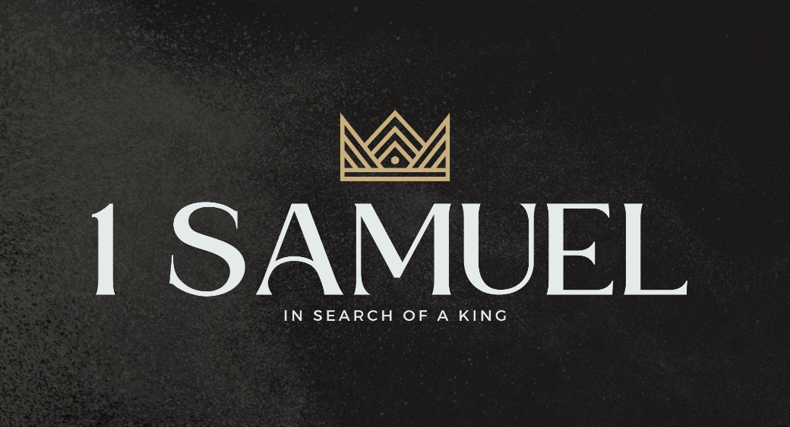

Welcome to Boyle Gospel Chapel
March 29, 2026

We’re glad you are here! We would like to thank you for sharing part of your day with us! With Bible-based teaching, family-centered programs, and a friendly atmosphere, Boyle Gospel Chapel opens its doors to you!

Boyle Gospel Chapel is affiliated with Village Missions of Canada. Learn more at: villagemissions.ca.

5101 – 5 Street, Boyle, AB T0A 0M0
(780) 689-4071
boylegospelchapel@gmail.com
www.boylegospelchapel.ca

Connect With Us



Worship With Us  Welcome & Announcements  Call to Worship (Psalm 113:1-3)  Leader: Praise the Lord!  Praise, O servants of the Lord,  praise the name of the Lord!  Blessed be the name of the Lord  from this time forth and forevermore!  From the rising of the sun to its setting,  the name of the Lord is to be praised!  Song: Jesus Bids Us Shine (#504)  Song: I’ll Be a Sunbeam (#483)  Praise & Prayer  Song: The Love of God (#286)  Song: He’s Everything to Me  Sermon  Sermon Series: 1 Samuel – In Search of a King  Sermon Title: “Lost and Found”  Sermon Text: 1 Samuel 9:1-10:16  Song: What a Day That Will Be  Benediction  Children’s Ministry  There is Sunday School during the sermon. There is an unsupervised nursery at the back of the church for parents with little ones.  Giving  If you would like to support the ministry of BGC, you may give:  - In the offering box at the back of the sanctuary.  - By e-transfer to: bgcbanking@gmail.com – please include your name and address for tax receipt purposes. |  | Upcoming Events  Tuesday Youth Bible Study @ 7:00pm at the Peters’  (5313 Willow Drive South, Boyle)  Wednesday Ladies Prayer Meeting @ 10:00am at the Chapel  Thursday Leadership Meeting @ 7:00pm at the Chapel  Friday Good Friday Service @ 700pm at the Chapel  Sunday Remembrance Service @ 10:00am  Family Bible Hour @ 11:00am  Sermon Text: 1 Samuel 10:17-27  April 11 Men’s Breakfast @ 8:00am at the Chapel  April 12 Chapel Service @ 3:00pm at Wildrose Villa  **We are planning a baptism ceremony during the Sunday morning service next week. If you have never been baptized, or if you would like more information about baptism, please see Pastor Brenden.  Deeper Study  Heidelberg Catechism  Q. 21) What is true faith?  A) True faith is not only a sure knowledge by which I hold as true all that God has revealed to us in his Word; it is also a wholehearted trust, which the Holy Spirit works in me by the gospel, that God has freely granted, not only to others but to me also, forgiveness of sins, eternal righteousness, and salvation. These gifts are purely of grace,  only because of Christ’s merit.  Chronological Bible Reading Plan  Sunday, March 29 – Joshua 22-24  Monday, March 30 – Judges 1-2  Tuesday, March 31 – Judges 3-5  Wednesday, April 1 – Judges 6-7  Thursday, April 2 – Judges 8-9  Friday, April 3 – Judges 10-12  Saturday, April 4 – Judges 13-15

