Sermon Notes

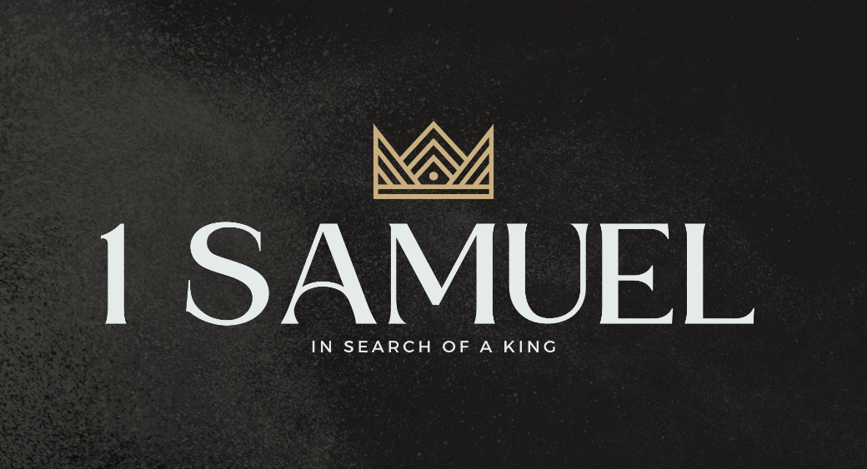

Welcome to Boyle Gospel Chapel
April 19, 2026

We’re glad you are here! We would like to thank you for sharing part of your day with us! With Bible-based teaching, family-centered programs, and a friendly atmosphere, Boyle Gospel Chapel opens its doors to you!

Boyle Gospel Chapel is affiliated with Village Missions of Canada. Learn more at: villagemissions.ca.

5101 – 5 Street, Boyle, AB T0A 0M0
(780) 689-4071
boylegospelchapel@gmail.com
www.boylegospelchapel.ca

Connect With Us



Worship With Us  Welcome & Announcements  Call to Worship (Psalm 105:1-3)  Leader: Oh give thanks to the Lord;  call upon his name;  make known his deeds among the peoples!  Sing to him, sing praises to him;  tell of all his wondrous works!  Glory in his holy name;  let the hearts of those  who seek the Lord rejoice!  Song: Great Is Thy Faithfulness (#39)  Song: His Mercy Is More  Praise & Prayer  Song: Come, Thou Fount of Every Blessing (#28)  Song: Take My Life and Let It Be (#380)  Sermon  Sermon Series: 1 Samuel – In Search of a King  Sermon Title: “A New Hope”  Sermon Text: 1 Samuel 11:1-15  Song: Trust and Obey (#196)  Benediction  Giving  If you would like to support the ministry of BGC, you may give:  - In the offering box at the back of the sanctuary.  - By e-transfer to: bgcbanking@gmail.com – please include your name and address for tax receipt purposes. |  | Upcoming Events  Tuesday Youth Bible Study @ 7:00pm at the Peters’  (5313 Willow Drive South, Boyle)  Wednesday Ladies Prayer Meeting @ 10:00am at the Chapel  Friday Youth Group @ 7:30pm at the Chapel  **Dress for the weather**  Sunday Remembrance Service @ 10:00am  Family Bible Hour @ 11:00am  Sermon Text: 1 Samuel 12:1-25  Fellowship Meal @ 12:15pm  May 1 Community Praise & Prayer @ 7:00pm at St. Alphonsus  Roman Catholic Church  Deeper Study  Heidelberg Catechism  Q. 24) How are these articles divided?  A) Into three parts: God the Father and our creation; God the Son  and our deliverance; and God the Holy Spirit and our sanctification.  Chronological Bible Reading Plan  Sunday, April 19 – 1 Samuel 28-31; Psalm 18  Monday, April 20 – Psalm 121; Psalm 123-125; Psalm 128-130  Tuesday, April 21 – 2 Samuel 1-4  Wednesday, April 22 – Psalm 6; Psalm 8-10; Psalm 14; Psalm 16;  Psalm 19; Psalm 21  Thursday, April 23 – 1 Chronicles 1-2  Friday, April 24 – Psalm 43-45; Psalm 49; Psalm 84-85; Psalm 87  Saturday, April 25 – 1 Chronicles 3-5

