Sermon Notes

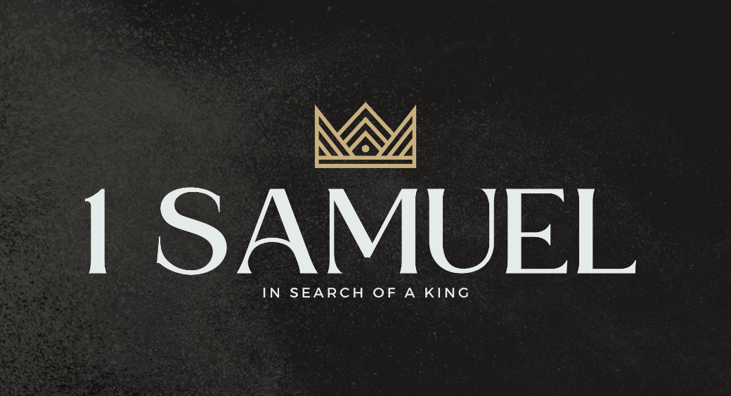

Welcome to Boyle Gospel Chapel
April 26, 2026

We’re glad you are here! We would like to thank you for sharing part of your day with us! With Bible-based teaching, family-centered programs, and a friendly atmosphere, Boyle Gospel Chapel opens its doors to you!

Boyle Gospel Chapel is affiliated with Village Missions of Canada. Learn more at: villagemissions.ca.

5101 – 5 Street, Boyle, AB T0A 0M0
(780) 689-4071
boylegospelchapel@gmail.com
www.boylegospelchapel.ca

Connect With Us



Worship With Us  Welcome & Announcements  Call to Worship (Based on Psalm 5:7; 130:5)  Leader: Through the abundance of the Lord's steadfast love,  enter his house and bow down before him.  ALL: I wait for the Lord, my soul waits,  and in his word I hope.  Song: Rock of Ages (#332)  Song: He Will Hold Me Fast  Praise & Prayer  Song: I Need Thee Every Hour (#431)  Song: Come Behold the Wondrous Mystery  Sermon  Sermon Series: 1 Samuel – In Search of a King  Sermon Title: “Remember What the Lord Has Done”  Sermon Text: 1 Samuel 12:1-25  Song: Christ Our Hope in Life and Death  Benediction  **Fellowship Meal to follow**  Giving  If you would like to support the ministry of BGC, you may give:  - In the offering box at the back of the sanctuary.  - By e-transfer to: bgcbanking@gmail.com – please include your name and address for tax receipt purposes. |  | Upcoming Events  Tuesday Youth Bible Study @ 7:00pm at the Peters’  (5313 Willow Drive South, Boyle)  Wednesday Ladies Prayer Meeting @ 10:00am at the Chapel  Friday Community Praise & Prayer @ 7:00pm at St. Alphonsus  Roman Catholic Church  Youth Group @ 7:30pm at the Chapel  Sunday Remembrance Service @ 10:00am  Family Bible Hour @ 11:00am  Sermon Text: 1 Samuel 13:1-23  May 9 Men’s Breakfast @ 8:00am at the Chapel  May 10 Chapel Service @ 3:00pm at Wildrose Villa  May 11 Leadership Meeting @ 7:00pm at the Chapel  May 16 Ladies Spring Tea & Fellowship @ 1:30pm at the Peters’  (5313 Willow Drive South, Boyle)  May 24 Creation Ministries Presentation @ 11:00pm at the Chapel  May 31 Celebration for Pastor Joe & Linda Kuraitis @ 11:00am  at Buffalo Lake Recreational Center; meal and program to  follow; RSVP by May 1 to: leana.patenaude@gmail.com  Deeper Study  Heidelberg Catechism  Q. 25) Since there is only one divine being, why do you speak of three: Father, Son, and Holy Spirit?  A) Because that is how God has revealed himself in his Word: these three  distinct persons are one, true, eternal God.  Chronological Bible Reading Plan  Sunday, April 26 – Psalm 73; Psalm 77-78  Monday, April 27 – 1 Chronicles 6  Tuesday, April 28 – Psalm 81; Psalm 88; Psalm 92-93  Wednesday, April 29 – 1 Chronicles 7-10  Thursday, April 30 – Psalm 102-104  Friday, May 1 – 2 Samuel 5:1-10; 1 Chronicles 11-12  Saturday, May 2 – Psalm 133

