Sermon Notes

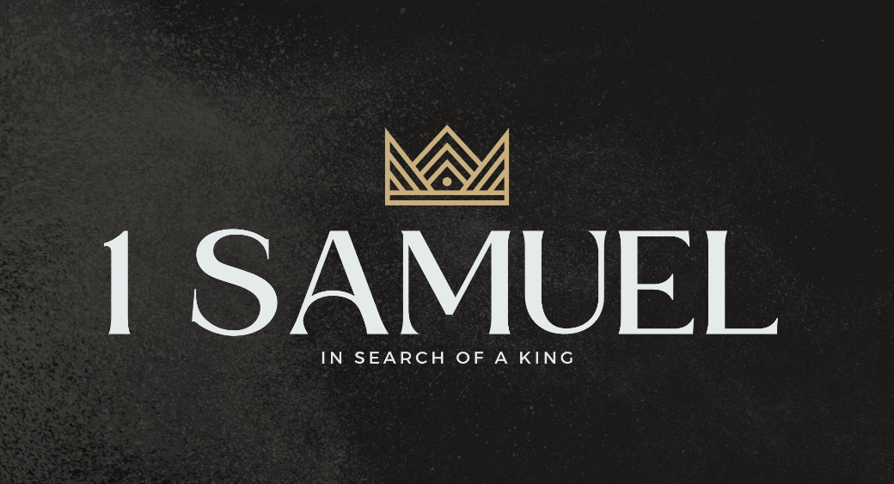

Welcome to Boyle Gospel Chapel
May 17, 2026

We’re glad you are here! We would like to thank you for sharing part of your day with us! With Bible-based teaching, family-centered programs, and a friendly atmosphere, Boyle Gospel Chapel opens its doors to you!

Boyle Gospel Chapel is affiliated with Village Missions of Canada. Learn more at: villagemissions.ca.

5101 – 5 Street, Boyle, AB T0A 0M0
(780) 689-4071
boylegospelchapel@gmail.com
www.boylegospelchapel.ca

Connect With Us



Worship With Us  Welcome & Announcements  Call to Worship (Psalm 99:1-3)  Leader: The Lord reigns;  let the peoples tremble!  He sits enthroned upon the cherubim;  let the earth quake!  The Lord is great in Zion;  he is exalted over all the peoples.  Let them praise your great  and awesome name!  Holy is he!  Song: Whate’er My God Ordains Is Right  Song: Holy, Holy, Holy  Praise & Prayer  Song: Before the Throne of God Above  Song: Yet Not I But Through Christ in Me  Sermon  Sermon Series: 1 Samuel – In Search of a King  Sermon Title: “The Danger of Foolish Leadership”  Sermon Text: 1 Samuel 14:24-52  Song: I Surrender All  Benediction  Giving  If you would like to support the ministry of BGC, you may give:  - In the offering box at the back of the sanctuary.  - By e-transfer to: bgcbanking@gmail.com – please include your name and address for tax receipt purposes. |  | Upcoming Events  Wednesday Ladies Prayer Meeting @ 10:00am at the Chapel  Friday Youth Group @ 7:30pm at the Chapel  Sunday Remembrance Service @ 10:00am  Family Bible Hour @ 11:00am  Speaker: Dr. Nathanael King (Creation Ministries)  Title: A Tale of Two Histories  Fellowship Meal @ 12:15pm  June 5 Community Praise & Prayer @ 7:00pm at the Chapel  May 10 – Did you know that when you give to the Baby Bottle  June 21 Campaign, you are helping mothers receive support that  continues a year after they give birth? The Pregnancy Care  Centre offers far more than pregnancy tests and accurate  options information. Through Pregnancy Plus classes, expecting parents learn about fetal development, healthy pregnancy, labour and delivery, parenting, essential life skills and much more. Please continue filling your bottles to help keep these free, life-affirming services available to the families who need them most. You can still sign out a bottle, or you can donate online at www.pregnancycarecentre.ca/bottle  Deeper Study  Heidelberg Catechism  Q. 28) How does the knowledge of God’s creation and providence help us?  A) We can be patient in adversity, thankful in prosperity, and for the future we can have good confidence in our faithful God and Father that no creature will separate us from his love. For all creatures are so completely in  his hand that without his will they can neither move nor be moved.  Chronological Bible Reading Plan  Sunday, May 17 – 2 Samuel 16-18  Monday, May 18 – Psalm 26; Psalm 40; Psalm 58; Psalm 61-62; Psalm 64  Tuesday, May 19 – 2 Samuel 19-21  Wednesday, May 20 – Psalm 5; Psalm 38; Psalm 41-42  Thursday, May 21 – 2 Samuel 22-23; Psalm 57  Friday, May 22 – Psalm 95; Psalm 97-99  Saturday, May 23 – 2 Samuel 24; 1 Chronicles 21-22; Psalm 30

