Sermon Notes

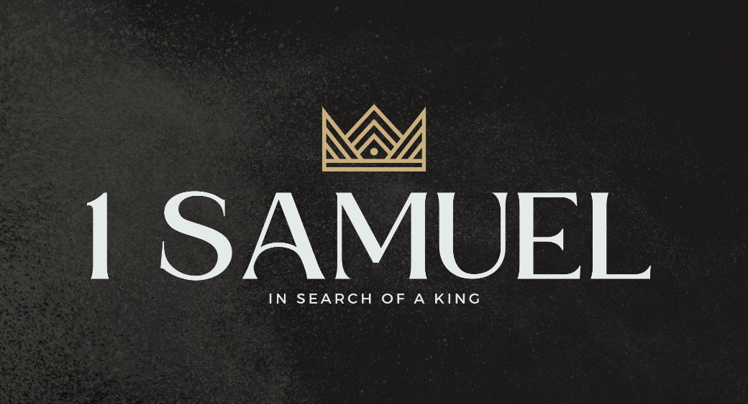

Welcome to Boyle Gospel Chapel
May 3, 2026

We’re glad you are here! We would like to thank you for sharing part of your day with us! With Bible-based teaching, family-centered programs, and a friendly atmosphere, Boyle Gospel Chapel opens its doors to you!

Boyle Gospel Chapel is affiliated with Village Missions of Canada. Learn more at: villagemissions.ca.

5101 – 5 Street, Boyle, AB T0A 0M0
(780) 689-4071
boylegospelchapel@gmail.com
www.boylegospelchapel.ca

Connect With Us



Worship With Us  Welcome & Announcements  Call to Worship (Based on Psalm 20:5; Isaiah 12:2)  Leader: Shout for joy over God's salvation,  and in the name of your God set up our banners!  ALL: God is my salvation;  I will trust, and will not be afraid;  for the Lord God is my strength and my song,  and he has become my salvation.  Song: Behold Our God  Song: O Worship the King  Praise & Prayer  Song: All Hail the Power of Jesus’ Name  Song: God Moves in a Mysterious Way  Sermon  Sermon Series: 1 Samuel – In Search of a King  Sermon Title: “The Folly of Disobedience”  Sermon Text: 1 Samuel 13:1-23  Song: Facing a Task Unfinished  Benediction  Giving  If you would like to support the ministry of BGC, you may give:  - In the offering box at the back of the sanctuary.  - By e-transfer to: bgcbanking@gmail.com – please include your name and address for tax receipt purposes. |  | Upcoming Events  Wednesday Ladies Prayer Meeting @ 10:00am at the Chapel  Friday Youth Group @ 7:30pm at the Chapel  Saturday Men’s Breakfast @ 8:00am at the Chapel  Sunday Remembrance Service @ 10:00am  Family Bible Hour @ 11:00am  Sermon Text: 1 Samuel 14:1-23  Fellowship Meal @ 12:15pm  Chapel Service @ 3:00pm at Wildrose Villa  May 11 Leadership Meeting @ 7:00pm at the Chapel  May 16 Ladies Spring Tea & Fellowship @ 1:30pm at the Peters’  (5313 Willow Drive South, Boyle)  May 24 Creation Ministries Presentation @ 11:00pm at the Chapel  **Dr. Nathanael King will be sharing how the message of creation in the book of Genesis supports the truth of the gospel and strengthens our confidence in the Bible. Bring your friends and family who are interested in the relationship between faith and science.  Deeper Study  Heidelberg Catechism  Q. 26) What do you believe when you say, “I believe in God, the Father Almighty, Creator of heaven and earth”?  A) That the eternal Father of our Lord Jesus Christ, who out of nothing created heaven and earth and everything in them, who still upholds and rules them by his eternal counsel and providence, is my God and Father for the sake of Christ his Son. I trust God so much that I do not doubt he will provide whatever I need for body and soul, and will turn to my good whatever adversity he sends upon me in this vale of tears. He is able to do this because he is almighty God; he desires to do this because he is a faithful  Father.  Chronological Bible Reading Plan  Sunday, May 3 – Psalm 106-107  Monday, May 4 – 2 Samuel 5:11-6:23; 1 Chronicles 13-16  Tuesday, May 5 – Psalm 1-2; Psalm 15; Psalm 22-24; Psalm 47; Psalm 68  Wednesday, May 6 – Psalm 89; Psalm 96; Psalm 100-101; Psalm 105; Psalm 132  Thursday, May 7 – 2 Samuel 7; 1 Chronicles 17  Friday, May 8 – Psalm 25; Psalm 29; Psalm 33; Psalm 36; Psalm 39  Saturday, May 9 – 2 Samuel 8-9; 1 Chronicles 18

