Sermon Notes

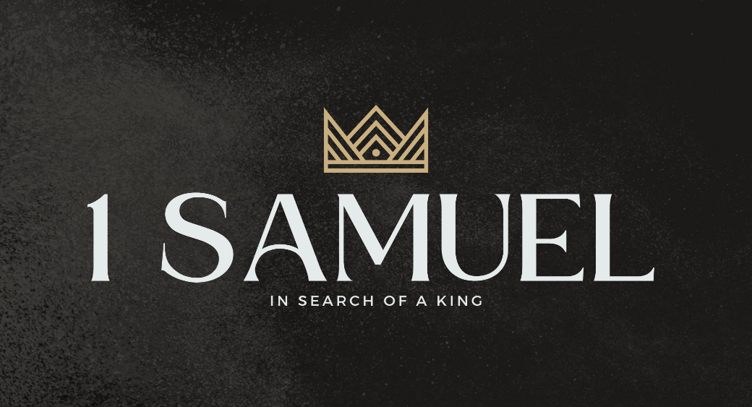

Welcome to Boyle Gospel Chapel
June 14, 2026

We’re glad you are here! We would like to thank you for sharing part of your day with us! With Bible-based teaching, family-centered programs, and a friendly atmosphere, Boyle Gospel Chapel opens its doors to you!

Boyle Gospel Chapel is affiliated with Village Missions of Canada. Learn more at: villagemissions.ca.

5101 – 5 Street, Boyle, AB T0A 0M0
(780) 689-4071
boylegospelchapel@gmail.com
www.boylegospelchapel.ca

Connect With Us



Worship With Us  Welcome & Announcements  Call to Worship (Based on Isaiah 55:1-3, 6)  Leader: Come, everyone who thirsts,  come to the waters;  those who have no money,  come and buy without price.  The Lord has made with you  an everlasting covenant.  Listen diligently to him, and hear,  that your soul may live.  Seek him while he may be found;  call upon him while he is near.  Song: I Have Decided to Follow Jesus (#299)  Song: Trusting Jesus (#440)  Praise & Prayer  Song: The Light of the World Is Jesus (#193)  Song: Does Jesus Care? (#373)  Sermon  Sermon Series: 1 Samuel – In Search of a King  Sermon Title: “To Obey Is Better Than Sacrifice”  Sermon Text: 1 Samuel 15:12-35  Song: I Believe in a Hill Called Mount Calvary (#302)  Benediction  **There is Fellowship Meal following the service**  Giving  If you would like to support the ministry of BGC, you may give:  - In the offering box at the back of the sanctuary.  - By e-transfer to: bgcbanking@gmail.com – please include your name and address for tax receipt purposes. |  | Upcoming Events  Today Chapel Service @ 3:00pm at Wildrose Villa  Wednesday Ladies Prayer Meeting @ 10:00am at the Chapel  Friday-Saturday Youth Group Year-End Campout @ Splane Campsite  drop-off at the Chapel @ 7:30pm on Friday; pick-up at the Chapel @ 2:00pm on Saturday; for more information,  contact Stephanie @ 780-689-8672  Sunday Remembrance Service @ 10:00am  Family Bible Hour @ 11:00am  Randy Jackson & Living Stone Band  May 10 – Do you have your bottle from the Baby Bottle Campaign for  June 21 the Pregnancy Care Centre? Please turn your bottle in next  Sunday. If you would still like to make a donation, you can  do so on their website: www.pregnancycarecentre.ca  Deeper Study  Heidelberg Catechism  Q. 32) But why are you called a Christian?  A) Because by faith I am a member of Christ and so I share in his anointing. I am anointed to confess his name, to present myself to him as a living sacrifice of thanks, to strive with a free conscience against sin and the devil  in this life, and afterward to reign with Christ over all creation for eternity.  Chronological Bible Reading Plan  Sunday, June 14 – 2 Chronicles 6-7; Psalm 136  Monday, June 15 – Psalm 134; Psalm 146-150  Tuesday, June 16 – 1 Kings 9 ; 2 Chronicles 8  Wednesday, June 17 – Proverbs 25-26  Thursday, June 18 – Proverbs 27-29  Friday, June 19 – Ecclesiastes 1-6  Saturday, June 20 – Ecclesiastes 7-12

