Sermon Notes

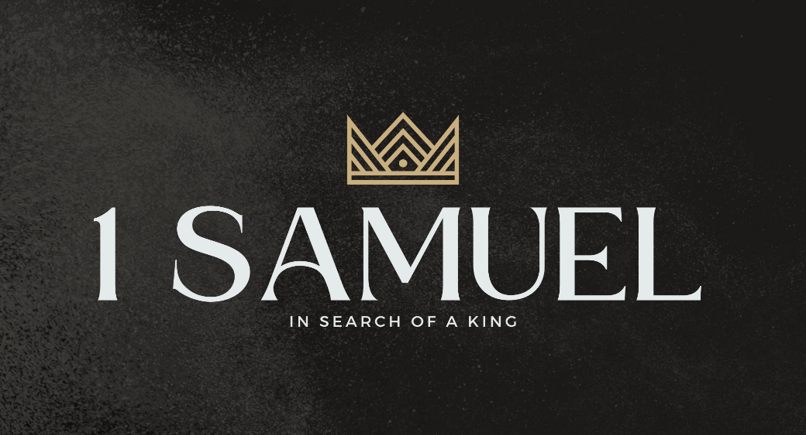

Welcome to Boyle Gospel Chapel
July 12, 2026

We’re glad you are here! Whether you are visiting for the first time or you’ve been here for years, we would like to thank you for sharing part of your day with us! With Bible-based teaching, family-centered programs, and a friendly atmosphere, Boyle Gospel Chapel opens its doors to you!

Boyle Gospel Chapel is affiliated with Village Missions of Canada. Learn more at: villagemissions.ca.

5101 – 5 Street, Boyle, AB T0A 0M0
(780) 689-4071
boylegospelchapel@gmail.com
www.boylegospelchapel.ca

Connect With Us



Worship With Us  Welcome & Announcements  Call to Worship (Psalm 33:6-8)  Leader: By the word of the Lord the heavens were made,  and by the breath of his mouth all their host.  He gathers the waters of the sea as a heap;  he puts the deeps in storehouses.  Let all the earth fear the Lord;  let all the inhabitants of the world stand in awe of him!  Song: O for a Thousand Tongues to Sing  Song: The Church’s One Foundation  Prayer & Praise  Song: May the Mind of Christ, My Savior  Song: Speak, O Lord  Sermon  Sermon Series: 1 Samuel – In Search of a King  Sermon Title: “Seeing the Battle Through Eyes of Faith”  Sermon Text: 1 Samuel 17:1-30  Song: Blest Be the Tie That Binds (#74)  Benediction  **There is no Sunday School for kids during the summer**  **There is Fellowship Meal following the service**  Giving  If you would like to support the ministry of BGC, you may give:  - In the offering box at the back of the sanctuary.  - By e-transfer to: bgcbanking@gmail.com – please include your name and address for tax receipt purposes. |  | Upcoming Events  Today Chapel Service @ 3:00pm at Wildrose Villa  Wednesday Ladies Prayer Meeting @ 10:00am at the Chapel  Sunday Remembrance Service @ 10:00am  Family Bible Hour @ 11:00am  Sermon Text: 1 Samuel 17:31-58  August 10-14 Emerald Crossing VBS @ 9:00am - 12:00pm  Vacation Bible School is a FREE 5-day summer  program for children ages 5-12. At Emerald Crossing  VBS, kids will explore God as Shepherd, Guide,  Comforter, Provider, and King. For more information  or to register your children, please visit:  www.boylegospelchapel.ca/vbs  Deeper Study  Heidelberg Catechism  Q. 36) How does the holy conception and birth of Christ benefit you?  A) He is our mediator and, in God’s sight, he covers with his  innocence and perfect holiness my sin, in which I was conceived.  Chronological Bible Reading Plan  Sunday, July 12 – Amos 6-9  Monday, July 13 – 2 Chronicles 27; Isaiah 9-12  Tuesday, July 14 – Micah 1-7  Wednesday, July 15 – 2 Chronicles 28; 2 Kings 16-17  Thursday, July 16 – Isaiah 13-17  Friday, July 17 – Isaiah 18-22  Saturday, July 18 – Isaiah 23-27

