Sermon Notes

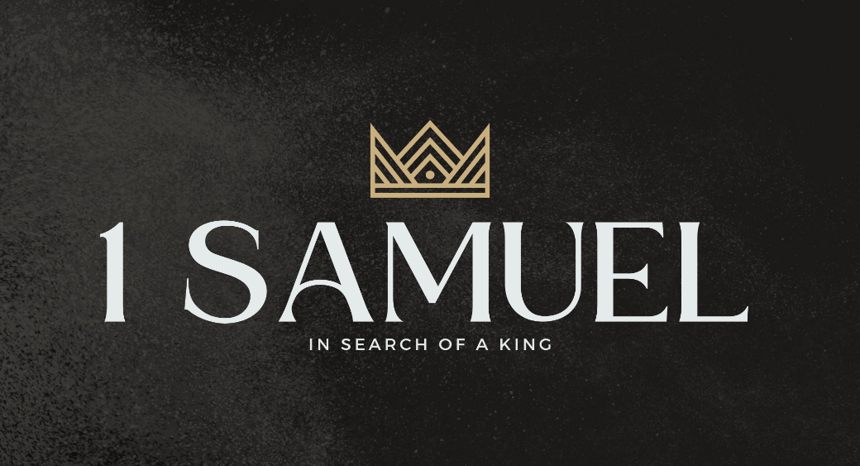

Welcome to Boyle Gospel Chapel
August 2, 2026

We’re glad you are here! Whether you are visiting for the first time or you’ve been here for years, we would like to thank you for sharing part of your day with us! With Bible-based teaching, family-centered programs, and a friendly atmosphere, Boyle Gospel Chapel opens its doors to you!

Boyle Gospel Chapel is affiliated with Village Missions of Canada. Learn more at: villagemissions.ca.

5101 – 5 Street, Boyle, AB T0A 0M0
(780) 689-4071
boylegospelchapel@gmail.com
www.boylegospelchapel.ca

Connect With Us



Worship With Us  Welcome & Announcements  Call to Worship (Based on Hebrews 12:18-19, 22, 24, 28-29)  Leader: You have not come to what may be touched, a blazing fire and darkness and gloom and a tempest and the sound of a trumpet and a voice whose words made the hearers beg that no further messages be spoken to them. But you have come to Jesus, the mediator of a new covenant, and to the sprinkled blood that speaks a better word than the blood of Abel. Therefore let us be grateful for receiving a kingdom that cannot be shaken, and thus let us offer to God acceptable worship, with reverence and  awe, for our God is a consuming fire.  Song: Come, Thou Fount of Every Blessing  Song: O Great God  Prayer & Praise  Song: Whate’er My God Ordains Is Right  Song: My Worth Is Not in What I Own  Sermon  Sermon Series: 1 Samuel – In Search of a King  Sermon Title: “Love Him or Fear Him”  Sermon Text: 1 Samuel 18:17-30  Song: Guide Me, O Thou Great Jehovah  Benediction  **There is no Sunday School for kids during the summer**  Giving  If you would like to support the ministry of BGC, you may give:  - In the offering box at the back of the sanctuary.  - By e-transfer to: bgcbanking@gmail.com – please include your name and address for tax receipt purposes. |  | Upcoming Events  Wednesday Ladies Prayer Meeting @ 10:00am at the Chapel  Thursday VBS Decorating Day @ 10:00am at the Chapel  Leadership Meeting @ 7:00pm at the Chapel  Saturday Men’s Breakfast @ 8:00am at the Chapel  Sunday Remembrance Service @ 10:00am  Family Bible Hour @ 11:00am  Sermon Text: 1 Samuel 19:1-24  Fellowship Meal @ 12:15pm  Chapel Service @ 3:00pm at Wildrose Villa  August 10-14 Emerald Crossing VBS @ 9:00am - 12:00pm  Vacation Bible School is a FREE 5-day summer  program for children ages 5-12. At Emerald Crossing  VBS, kids will explore God as Shepherd, Guide,  Comforter, Provider, and King. For more information  or to register your children, please visit:  www.boylegospelchapel.ca/vbs  Deeper Study  Heidelberg Catechism  Q. 39) Is it significant that he was “crucified” instead of dying some other way?  A) Yes. By this death I am convinced that he shouldered the curse  which lay on me since death by crucifixion was cursed by God.  Chronological Bible Reading Plan  Sunday, August 2 – 2 Kings 20-21  Monday, August 3 – 2 Chronicles 32-33  Tuesday, August 4 – Nahum 1-3  Wednesday, August 5 – 2 Kings 22-23; 2 Chronicles 34-35  Thursday, August 6 – Zephaniah 1-3  Friday, August 7 – Jeremiah 1-3  Saturday, August 8 – Jeremiah 4-6

