Sermon Notes

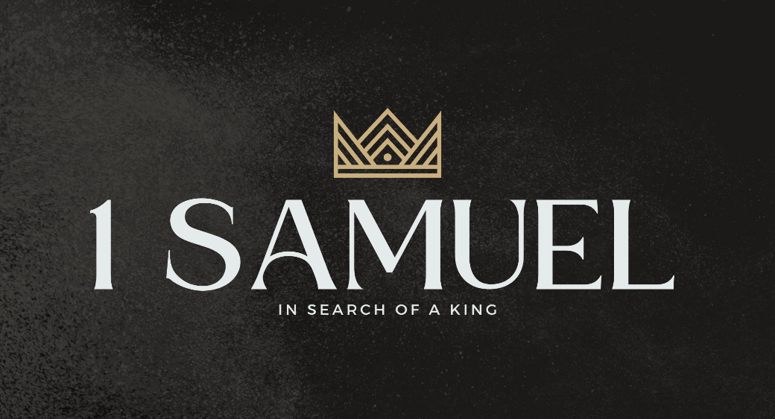

Welcome to Boyle Gospel Chapel
August 9, 2026

We’re glad you are here! Whether you are visiting for the first time or you’ve been here for years, we would like to thank you for sharing part of your day with us! With Bible-based teaching, family-centered programs, and a friendly atmosphere, Boyle Gospel Chapel opens its doors to you!

Boyle Gospel Chapel is affiliated with Village Missions of Canada. Learn more at: villagemissions.ca.

5101 – 5 Street, Boyle, AB T0A 0M0
(780) 689-4071
boylegospelchapel@gmail.com
www.boylegospelchapel.ca

Connect With Us



Worship With Us  Welcome & Announcements  Call to Worship (Based on Colossians 1:4-5, 15-18)  Leader: Christ is the image of the invisible God,  the firstborn of all creation.  He created all things and he is before all things,  and in him all things hold together.  And he is the head of the body, the church.  He is the beginning, the firstborn from the dead,  that in everything he might be preeminent.  Because of your faith in Christ  and the hope laid up for you in heaven –  Christians, come to his throne and worship the King!  Song: Rejoice, the Lord is King  Song: Crown Him with Many Crowns  Prayer & Praise  Song: All Glory Be to Christ  Song: Completely Known, Completely Loved  Sermon  Sermon Series: 1 Samuel – In Search of a King  Sermon Title: “Against the Lord and Against His Anointed”  Sermon Text: 1 Samuel 19:1-24  Song: Jesus Shall Reign  Benediction  **There is no Sunday School for kids during the summer**  **There is Fellowship Meal following the service**  Giving  If you would like to support the ministry of BGC, you may give:  - In the offering box at the back of the sanctuary.  - By e-transfer to: bgcbanking@gmail.com – please include your name and address for tax receipt purposes. |  | Upcoming Events  Monday - Emerald Crossing VBS @ 9:00am-12:00pm at the  Friday Chapel  Wednesday No Ladies Prayer Meeting this week  Sunday Remembrance Service @ 10:00am  Family Bible Hour @ 11:00am  Sermon Text: Mark 4:35-41  August 10-14 Emerald Crossing VBS @ 9:00am - 12:00pm  Vacation Bible School is a FREE 5-day summer  program for children ages 5-12. At Emerald Crossing  VBS, kids will explore God as Shepherd, Guide,  Comforter, Provider, and King. For more information  or to register your children, please visit:  www.boylegospelchapel.ca/vbs  Deeper Study  Heidelberg Catechism  Q. 40) Why did Christ have to suffer death?  A) Because God’s justice and truth require it: nothing else could pay  for our sins except the death of the Son of God.  Chronological Bible Reading Plan  Sunday, August 9 – Jeremiah 7-9  Monday, August 10 – Jeremiah 10-13  Tuesday, August 11 – Jeremiah 14-17  Wednesday, August 12 – Jeremiah 18-22  Thursday, August 13 – Jeremiah 23-25  Friday, August 14 – Jeremiah 26-29  Saturday, August 15 – Jeremiah 30-31

