Sermon Notes

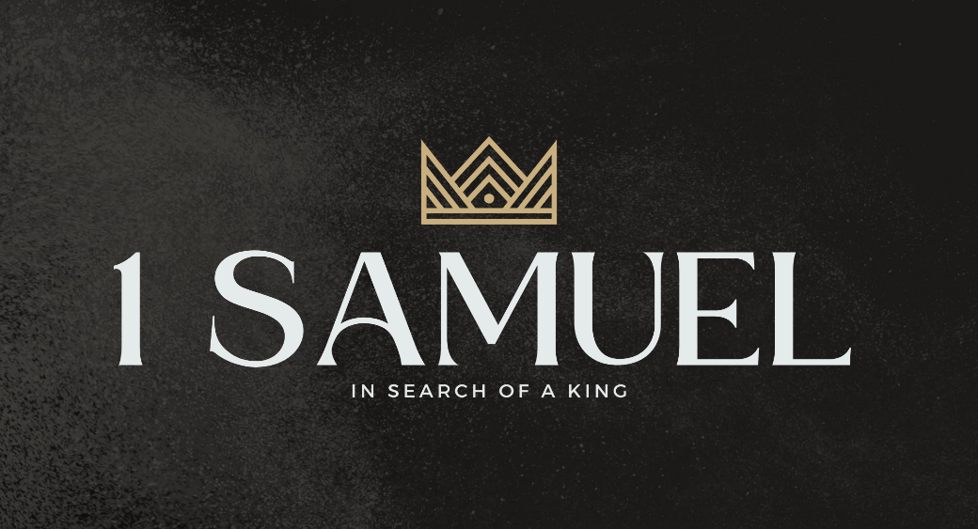

Welcome to Boyle Gospel Chapel
September 13, 2026

We’re glad you are here! Whether you are visiting for the first time or you’ve been here for years, we would like to thank you for sharing part of your day with us! With Bible-based teaching, family-centered programs, and a friendly atmosphere, Boyle Gospel Chapel opens its doors to you!

Boyle Gospel Chapel is affiliated with Village Missions of Canada. Learn more at: villagemissions.ca.

5101 – 5 Street, Boyle, AB T0A 0M0
(780) 689-4071
boylegospelchapel@gmail.com
www.boylegospelchapel.ca

Connect With Us



Worship With Us  Welcome & Announcements  Call to Worship (Based on Psalm 18:3; 28:2)  Leader: Call upon the Lord,  who is worthy to be praised.  ALL: Hear the voice of my pleas for mercy,  when I cry to you for help,  when I lift up my hands  toward your most holy sanctuary.  Song: O God, Our Help in Ages Past  Song: A Shelter in the Time of Storm  Prayer & Praise  Song: God Is Our Strength and Refuge  Song: ‘Tis So Sweet to Trust in Jesus  Sermon  Sermon Series: 1 Samuel – In Search of a King  Sermon Title: “Have You Not Read What David Did?”  Sermon Text: 1 Samuel 21:1-22:5  Song: He Will Hold Me Fast  Benediction  **Fellowship Meal to follow**  Children’s Ministry  Sunday School is available for children during the sermon. For parents with smaller children, an unsupervised nursery is available at the back of the church. |  | Upcoming Events  Today Chapel Service @ 3:00pm at Wildrose Villa  Wednesday Ladies Prayer Meeting @ 10:00am at the Chapel  Sunday Remembrance Service @ 10:00am  Family Bible Hour @ 11:00am  Sermon Text: 1 Samuel 22:6-23  September 20 Sunday School Picnic @ Splane Campsite  (200068, Township Road 642, east of Range Road 201)  Come straight to the campsite after church for a time  of fellowship, with lunch served shortly afterward.  Meat will be provided. Please bring a chair and either  a side or a dessert. Dress for outdoor weather.  Deeper Study  Heidelberg Catechism  Q. 45) How does Christ’s resurrection benefit us?  A) First, by his resurrection he has overcome death, so that he might make us share in the righteousness he obtained for us by his death. Second, by his power we too are already raised to a new life. Third,  Christ’s resurrection is a sure pledge to us of our blessed resurrection.  Chronological Bible Reading Plan  Sunday, September 13 – Joel 1-3  Monday, September 14 – Daniel 1-3  Tuesday, September 15 – Daniel 4-6  Wednesday, September 16 – Daniel 7-9  Thursday, September 17 – Daniel 10-12  Friday, September 18 – Ezra 1-3  Saturday, September 19 – Ezra 4-6; Psalm 137

