Sermon Notes

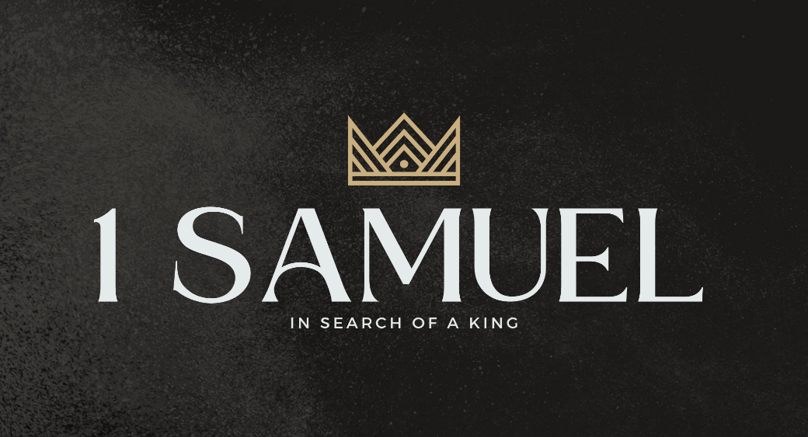

Welcome to Boyle Gospel Chapel
October 4, 2026

We are glad you are here! Whether you are visiting for the first time or you have been here for years, we would like to thank you for sharing part of your day with us! With Bible-based teaching, family-centered programs, and a friendly atmosphere, Boyle Gospel Chapel opens its doors to you!

Boyle Gospel Chapel is affiliated with Village Missions of Canada. Learn more at: villagemissions.ca.

5101 – 5 Street, Boyle, AB T0A 0M0
(780) 689-4071
boylegospelchapel@gmail.com
www.boylegospelchapel.ca

Connect With Us



Worship With Us  Welcome & Announcements  Call to Worship (Based on Psalm 4:3, 5)  Leader: The Lord has set apart the godly for himself;  the Lord hears those who call to him.  Bring your offerings to him  and put your trust in the Lord.  Song: Take Time to Be Holy (#415)  Song: He Touched Me (#227)  Scripture Reading  Prayer & Praise  Song: Jesus Loves Me (#251)  Song: Once for All (#346)  Sermon  Sermon Series: 1 Samuel – In Search of a King  Sermon Title: “Therefore We Do Not Lose Heart”  Sermon Text: 1 Samuel 23:1-29  Song: Bringing In the Sheaves (#463)  Benediction  Children’s Ministry  Sunday School is available for children during the sermon. For parents with smaller children, an unsupervised nursery is available at the back of the church. |  | Upcoming Events  Today Opening Chapel & Library Dedication @ 7:00pm at  Keywaytin Discipleship Centre, Lac La Biche  Tuesday Youth Bible Study @ 7:00pm at the Peters’  (5313 Willow Drive South, Boyle)  Wednesday Ladies Prayer Meeting @ 10:00am at TBD  Adult Bible Study @ 7:00pm at the Peters’  (5313 Willow Drive South, Boyle)  Friday **No Youth Group this week**  Saturday Men’s Breakfast @ 8:00am at the Chapel  Sunday Remembrance Service @ 10:00am  Family Bible Hour @ 11:00am  Sermon Text: 1 Samuel 24:1-22  Fellowship Meal @ 12:15pm  Chapel Service @ 3:00pm at Wildrose Villa  October 18 Seeking God for Alberta: An Evening of Prayer for the  Referendum @ 7:00pm at the Chapel  November 15 Operation Christmas Child Shoebox Collection Date  Deeper Study  Heidelberg Catechism  Q. 48) If his humanity is not present where his divinity is, then aren't the two natures of Christ separated from each other?  A) Certainly not. Since divinity is not limited and is present everywhere, it is evident that Christ’s divinity is surely beyond the bounds of the humanity that has been taken on, but at the same time his divinity is in and remains  personally united to his humanity.  Chronological Bible Reading Plan  Sunday, October 4 – Matthew 3; Mark 1; Luke 3  Monday, October 5 – Matthew 4; Luke 4-5; John 1:15-51  Tuesday, October 6 – John 2-4  Wednesday, October 7 – Mark 2  Thursday, October 8 – John 5  Friday, October 9 – Matthew 12:1-21; Mark 3; Luke 6  Saturday, October 10 – Matthew 5-7

