Sermon Notes

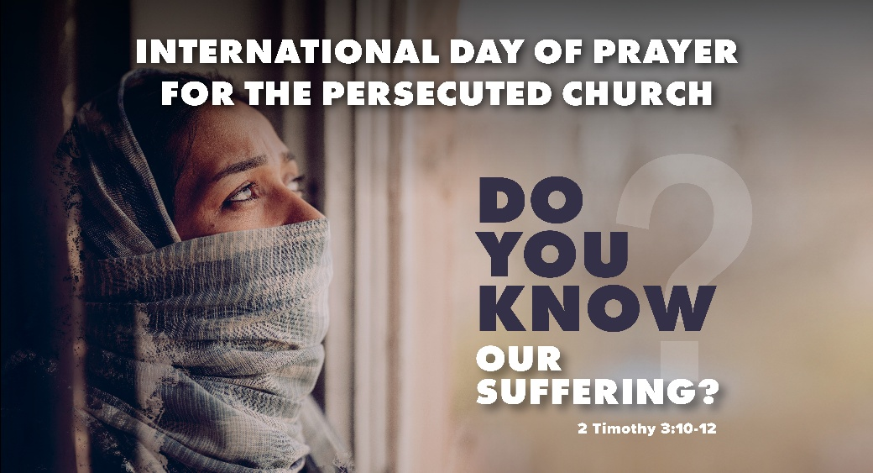

Welcome to Boyle Gospel Chapel
November 1, 2026

We are glad you are here! Whether you are visiting for the first time or you have been here for years, we would like to thank you for sharing part of your day with us! With Bible-based teaching, family-centered programs, and a friendly atmosphere, Boyle Gospel Chapel opens its doors to you!

Boyle Gospel Chapel is affiliated with Village Missions of Canada. Learn more at: villagemissions.ca.

5101 – 5 Street, Boyle, AB T0A 0M0
(780) 689-4071
boylegospelchapel@gmail.com
www.boylegospelchapel.ca

Connect With Us



Worship With Us  Welcome & Announcements  Call to Worship (Based on Psalm 9:1-2)  Leader: Give thanks to the Lord with your whole heart;  recount all of his wonderful deeds.  Be glad and exult in him;  sing praise to the Most High.  Song: Before the Throne of God Above  Song: Only Trust Him (#312)  International Day of Prayer for the Persecuted Church  Prayer & Praise  Song: I Know Whom I Have Believed (#229)  Song: My Faith Looks Up to Thee (#33)  Sermon  Sermon Series: 1 Samuel – In Search of a King  Sermon Title: “Behind Enemy Lines”  Sermon Text: 1 Samuel 27:1-28:2  Song: A Shelter in the Time of Storm (#180)  Benediction  Children’s Ministry  Sunday School is available for children during the sermon. For parents with smaller children, an unsupervised nursery is available at the back of the church. |  | Upcoming Events  Tuesday Youth Bible Study @ 7:00pm at the Peters’  (5313 Willow Drive South, Boyle)  Wednesday Ladies Prayer Meeting @ 10:00am at the Chapel  Adult Bible Study @ 7:00pm at the Peters’  (5313 Willow Drive South, Boyle)  Thursday Leadership Meeting @ 7:00pm at the Chapel  Friday Community Praise & Prayer @ 7:00pm at St. Alphonsus  Roman Catholic Church  Youth Group @ 7:30pm at the Chapel  Sunday Remembrance Service @ 10:00am  Family Bible Hour @ 11:00am  Sermon Text: 1 Samuel 28:3-25  Fellowship Meal @ 12:15pm  Chapel Service @ 3:00pm at Wildrose Villa  November 14 Men’s Breakfast @ 8:00am at the Chapel  November 15 Operation Christmas Child Shoebox Collection Date  Deeper Study  Heidelberg Catechism  Q. 52) How does Christ’s return “to judge the living and the dead” comfort you?  A) In all distress and persecution, with uplifted head, I confidently await the very judge who has already offered himself to the judgment of God in my place and removed the whole curse from me. Christ will cast all his enemies and mine into everlasting condemnation, but will take me and all his chosen  ones to himself into the joy and glory of heaven.  Chronological Bible Reading Plan  Sunday, November 1 – Matthew 20-21  Monday, November 2 – Luke 18:15-19:48  Tuesday, November 3 – Mark 11; John 12  Wednesday, November 4 – Matthew 22; Mark 12  Thursday, November 5 – Matthew 23; Luke 20-21  Friday, November 6 – Mark 13  Saturday, November 7 – Matthew 24

